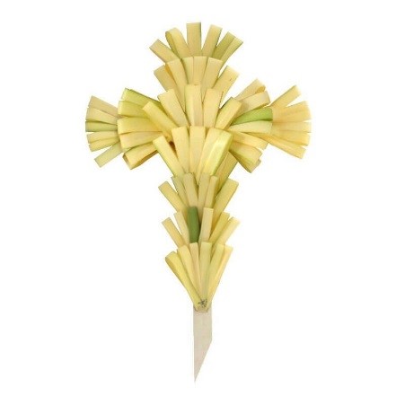
Grace Lutheran Church
Palm Sunday
March 29, 2026
Memorial Cross
In the memory of
Loved Ones and Friends

Please print the names below

The cost is $5.00 per Name.

1. In memory of ____________________________________________
By ____________________________________________________
2. In memory of ____________________________________________
By ____________________________________________________
3. In memory of ____________________________________________
By ____________________________________________________
4. In memory of ____________________________________________
By ____________________________________________________
5. In memory of ____________________________________________
By ____________________________________________________
6. In memory of ____________________________________________
By ____________________________________________________
7. In memory of ____________________________________________
By ____________________________________________________

The Deadline is Thursday, March 26, 2026

Please Place in Offering Plate or mail to:
Grace Lutheran Church
PO Box 436
Bayonne, NJ 07002

